The calculation is made on the basis of comparison of model components, documents - the price lists available components from suppliers assortments, and the so-called the rules by which the application searches and establishes a correspondence (in English - match). "Satellites" base of local suppliers - a document in Excel format, is stored in files with which they are updated TSmatch team of Internet hyperlink stored in the system, but only when the user

The calculation is based on the comparison of model components , documents - the price lists, which shows the availability of the necessary components from suppliers assortments and so-called **rules** by which the application searches and establishes a correspondence (**match**). "Satellites" base of local suppliers are a documents in Excel format, stored in files which can be updated by TSmatch using an Internet hyperlink stored in the system, but only when the user deems it necessary.

The data in the TSmatch report can be changed by replacing one supplier to another using the simple editing in Excel, for example, from another city or on the register of the building organization warehouse. Certainly, the structure of the data in this - or an alternative document have to be already known by TSmatch, or included in TSmatch directory by application in semi-automatic mode by the user’s command.

Application runs by pressing the button in the Tekla’s environment or as a regular Windows program. In the first case the current model in Tekla is processed; otherwise the localisation of Tsmatch’s files, database-assortments, rules and models is specified in the dialog with user.

The rules that define the correspondence between the profiles of the model components and similar data in satellite bases are very simple. They can be easily created and edited by every member of the design and construction organization or a member of the business department on the basis of similar rules already recorded in TSmatch. It is important that this work does not require Tekla, because Excel file can be sent or copied. Even for quite large models file is small, since TSmatch includes information on data : material profile, summing weight, volume and so on. In this way, the model which comprises several hundred thousand elements, usually obtained in grouped form file of several hundred lines for several minutes.

After the changes in the TSmatch report file, actually in the register of the used assortments, you can transfer the edited file back into Tekla Structures, the changes in the model are highlighted. Confirmation of the possibility of replacing is the responsibility of the designer; if he/she confirms the possibility of replacing, model is saved with changes.

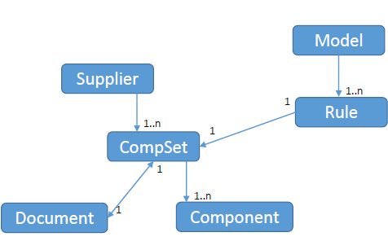Pic.1 shows UML diagram, which illustrates how Tsmatch works.